Deep Learning and Hybrid Ensemble Approaches for Smartphone Screen Surface Defect Detection
Prerona Karmakar  School of Computer Engineering  KIIT Deemed to be University  Bhubaneshwar, Odisha, India prerona.new123@gmail.com | Aadi Poddar  School of Computer Engineering  KIIT Deemed to be University  Bhubaneshwar, Odisha, India  aadipoddarmail@gmail.com | Mahendra Kumar Gourisaria  School of Computer Engineering  KIIT Deemed to be University  Bhubaneshwar, Odisha, India  mkgourisaria2010@gmail.com
Aadi Poddar  School of Computer Engineering  KIIT Deemed to be University  Bhubaneshwar, Odisha, India  aadipoddarmail@gmail.com | Aadi Poddar  School of Computer Engineering  KIIT Deemed to be University  Bhubaneshwar, Odisha, India  aadipoddarmail@gmail.com | Mahendra Kumar Gourisaria  School of Computer Engineering  KIIT Deemed to be University  Bhubaneshwar, Odisha, India  mkgourisaria2010@gmail.com

Abstract – Mobile phone manufacturing and supply chain requires strict quality control to detect surface defects such as oil marks, scratches, and stains. Manual and visual inspection of defects and dents are extremely slow, inconsistent, and prone to human error. They are unable to detect defects that are minute and not visible to the naked eye. This study compares and evaluates ten different deep learning models for automatic four-class surface defect classification on mobile phone screens. Eight backbone architectures were evaluated such as VGG16, ResNet50, MobileNetV2, EfficientNet-B0, DeiT-Small, Swin Transformer Tiny, DINOv2-Small, and ConvNeXt-Tiny. Along with these two hybrid approaches were also tested such as a CNN ensemble fusing ResNet50, VGG16, and MobileNetV2 features, and a DINOv2 foundation model paired with XGBoost. All features were extracted from frozen ImageNet-pretrained backbones and cached using FAISS for efficiency. The DeiT-Small vision transformer outperformed with the best overall performance with 99.45% accuracy, 0.9958 macro F1-score, and 0.9998 macro-AUC.
Keywords—Mobile Phone Defect Detection, Transfer Learning, Vision Transformers, Convolutional Neural Networks, FAISS, DeiT, SMOTE

Introduction
The global smartphone and electronic market have grown rapidly over the past decade. Billions of mobile and electronic devices are manufactured every year across factories worldwide. Handling and maintaining such a large production volume and ensuring that each device meets visual quality standards is an engineering challenge. Brand reputation can be easily damaged even if a small percentage of defective units reach the consumers. This increases the demand for robust and reliable quality inspection systems at every stage of the manufacturing pipeline [1].
The most commonly identified quality issue encountered during production are surface defects on mobile phone screens. These defects include oil residue from handling, scratches from contact with hard surfaces during assembly, and stains from environmental contamination or chemical processes [2]. Oil marks show visual characteristics such as they tend to appear as diffuse, slightly translucent patches. On the other hand, scratches show up as thin, elongated lines with sharp edges. The stains show irregular discolored regions on the screen surface. A "good" unit that is free of any defects or dents, by contrast, has a clean and uniform appearance.
Computer vision, deep learning and machine learning have emerged as promising alternatives for automating tasks that require visual inspection. Convolutional neural networks show strong results in image classification tasks. The idea is to train a neural network on labeled images of defective and non-defective surfaces so that it learns to distinguish between different defect categories. CNN process images through local sliding filters [3]. Transfer learning has also reduced the barriers in specialized domains like manufacturing. Transfer learning has also emerged a significant and practical strategy in industrial imaging as it handles large labeled datasets. It takes a neural network that has been trained on a large dataset of general images and freezes its learned feature extraction layers [4]. It then attaches a new classification head tailored to the specific task. Vision transformers use a self-attention mechanism that allows every part of the image to attend to every other part of the image [5]. This study uses models like DeiT, Swin Transformer, and DINOv2 which show different approaches to applying the transformer idea to images [6].
A large number of studies and researches have been conducted in the field of smartphone defect detection. Most of the works evaluate only one or two model architectures, making it difficult to draw reliable conclusions [7]. The study addresses this gap and gained superior results by evaluating ten different deep learning models for four-class mobile phone surface defect classification. The study includes four traditional CNN architectures (VGG16, ResNet50, MobileNetV2, and EfficientNet-B0), three vision transformer models (DeiT-Small, Swin Transformer Tiny, and DINOv2-Small), one modern CNN (ConvNeXt-Tiny), and two hybrid approaches (a CNN feature ensemble and a DINOv2 plus XGBoost combination).
Features were extracted from frozen pretrained backbones and cached to disk using FAISS. The study shows the effectiveness of vision transformers for industrial defect classification, with DeiT-Small achieving 99.45% accuracy. The study uses FAISS-based feature caching to make the entire training and evaluation pipeline efficient and robust. All the models used in the study were evaluated under identical preprocessing, splitting, and evaluation conditions for the given dataset.
Machine learning algorithms can also be used in different other fields related to Mobile Defect Detection like Lung Cancer Prediction, Corn Variety Classification and Detection, Surface Defect Detection etc. The rest of the paper is organized like: Section II. Literature Review, covering significant publications on the subject; Section III. tells about Methods and Materials, providing details on the classifiers and strategies employed; Section IV covers Implementation and Results, contrasting the performance of various regression models to determine the most effective model; and Section V. Conclusion and Future Work, summarizing findings and proposing future research directions followed by references.

Literature Review
This section provides a review of various research works performed by various scientist and machine learning engineers from all over the world in the field of Mobile Phone Defect Detection in industries.
K. Chen et.al (2026) [8] in the study proposed a screen-printed ink protrusion defect detection approach based on rowwise scanning statistics and image enhancement. Canny edge detection is used to extract the bottom contour, and Hough line fitting is used to choose a bottom reference line. The YOLOv11n model achieved 92% detection accuracy in the research, producing 3 false positives and 21 false negatives on this dataset. C. Zhang et.al (2026) [9] in the study presented RGM-YOLO (RefConv–GhostNet–CBAM-enhanced YOLOv8), which uses RefConv and GhostNet modules to incorporate deformable convolution and channel attention. According to experimental data, RGM-YOLO outperforms the baseline model, YOLOv8, by 2.4% and 11.2%, achieving 94.2% in mAP50 and 67.3% in mAP90–95. The FPS rises from 78 to 102 but the number of parameters and GFLOPs decreases by 4.2M and 2.5G, respectively.
P. Wu et.al (2025) [10] in the study proposed SSGDD-YOLO (you only look once), a smartphone screen glass defect detection model based on an improved YOLOv7 framework with multiscale feature fusion and multiattention. The created SPPCSPC-I module improves the multiscale feature extraction capabilities with a variety of receptive fields. According to the results, among all the approaches evaluated, the suggested SSGDD-YOLO model can reach the greatest mAP of 62.46%. R. Mohandas et.al (2025) [11] illustrated the use of cellphones with the application of Deep Learning-based Computer Vision for Remanufacturing end-of-life consumer electronics goods. A variety of deep learning models, such as YOLOv7, YOLOv8, YOLO11 variations, and Mask R-CNN, were trained on the dataset. This decreased inference time with a high accuracy of 70.4% shows that a reliable, quick, and accurate grading is accomplished.
Y. Zhou et.al (2024) [12] achieved quick global detection of high-resolution image acquisition and suggested a unique approach (ViT-Faster-RCNN) that combines Vision Transformer (ViT) with Faster-RCNN to identify flaws in glass covers. The Transformer framework's encoding and decoding structures are included into the backbone network to effectively improve the model's capacity to extract global and contextual information. The results of the experiments show that the suggested approach can reliably and automatically identify minor flaws in the glass cover plates, with an accuracy rate of up to 97.9%. D. Zhang et.al (2024) [13] provided and experimentally illustrated a new flaw detection technique for the smart meter's LCD screen. The Convolutional Neural Network (CNN) that I employed is built and trained to identify the flaws in the processed photos. It consists of four convolution layers, four pooling layers, and two fully connected layers. According to the experimental findings, the method's accuracy, precision, recall, and F1-score are 97.25%, 97.49%, 97%, and 97.24%, respectively.
Y. Mao et.al (2023) [14] enhanced the detection network's feature extraction and information exchange capabilities. The study suggests a new network called Dy-YOLO v5s, adds an attention module to the residual structure. The experimental findings show that the mean average accuracy (mAP) of Dy-YOLO v5s, precision rate (P), and recall rate (R) attain values of 96.2%, 92.6%, and 93.1%, respectively, when the intersection over union (IOU) threshold is set to 50%. C. Zhou et.al (2023) [15] took use of category-wise dependence, image-wise relations, and interactions between them, for a graph reasoning module that is stacked on top of a classification module consisting of the FC2module and the GR-module. The two-stage network delivers the greatest results, with 97.7% accuracy and 97.3% F-measure, according to experiments on the mobile screen defect dataset.
A constructive and detailed analysis of all the literature reviews alongside their performance scores and accuracy is shown in Table.1.
- Analysis of Literature Review
Year | Best Model | Primary Author | Results
[8] 2026 | YOLOv11n | K. Chen | 92%  Accuracy
[9] 2026 | RGM-YOLO | C. Zhang | 94.2%  Accuracy
[10] 2025 | SSGDD-YOLO | P. Wu | 62.46% Accuracy
[11] 2025 | YOLOv8x | R. Mohandas | 70.4% Accuracy
[12] 2024 | ViT-Faster-RCNN | Y. Zhou | 97.9% Accuracy
[13] 2024 | CNN | D. Zhang | 97.25%  Accuracy
[14] 2023 | Dy-YOLO v5s | Y. Mao | 96.2%  Accuracy
[15] 2023 | FC2module  GR-module | C. Zhou | 97.7%  Accuracy

PROPOSED METHODS
Different machine learning models work differently, and it is entirely up to us as to which model we should train to obtain the best results. The study includes four traditional CNN architectures (VGG16, ResNet50, MobileNetV2, and EfficientNet-B0), three vision transformer models (DeiT-Small, Swin Transformer Tiny, and DINOv2-Small), one modern CNN (ConvNeXt-Tiny), and two hybrid approaches (a CNN feature ensemble and a DINOv2 plus XGBoost combination). These algorithms are discussed further, along with the results obtained after training the models. Subsection A. described the Dataset Used, B. Hardware and Software used, C. Data Preprocessing, D. talk about Splitting the Data, E. Model Workflow Diagram, F. Correlation Matrix, G. FAISS, H. SMOTE, I. PCA, J. Technology Used and K. Evaluation Metrices.

Dataset Used
This study uses the Mobile Phone Defect Segmentation Dataset from Kaggle. The dataset contains 1,220 images of mobile phone screen surfaces with four classes as good (20 images), oil (400 images), scratch (400 images), and stain (400 images). All images in the dataset have a resolution of 1920 by 1080 pixels in JPEG format. The dataset has and imbalance ratio of 1:20 as the good class has only 20 samples compared to 400 for each defect class. This imbalance ration is a realistic reflection of production environments as the non-defective units captured for training are often limited [16]. Fig-1 shows the sample images from the Mobile Phone Defect Segmentation Dataset used in this study.
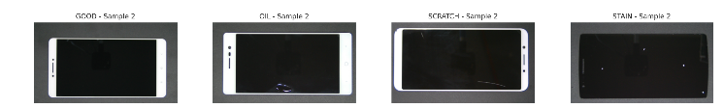
- Sample Images from Mobile Phone Defect Segmentation Dataset

Hardware and software
The training and testing of all models were done on a workstation running Windows 11 Home Single Language OS and with an Intel 12th Gen Intel(R) Core (TM) i7-1255U 1700 MHz CPU, 10 cores, 12 logical processors and 16 GB RAM. Scikit-Learn modules for the training of the models used Python 3 carried out on TPU of Google Collab.

Data Preprocessing
The study satisfies the input size requirements of the pretrained backbone networks; all images were resized to 224 by 224 pixels. The input images were normalized using the channel wise mean and standard deviation of the ImageNet dataset (mean = 0.485, 0.456, 0.406; std = 0.229, 0.224, 0.225). To enhance model robustness and reduce overfitting, the training data were augmented using random horizontal flips (p = 0.5), random vertical flips (p = 0.3), rotations within ±15°, color jitter (brightness = 0.2, contrast = 0.2), and affine transformations with translations up to 10% of the image dimensions. To mitigate class imbalance in the training data, the Synthetic Minority Over-sampling Technique (SMOTE) was employed in the feature space to generate synthetic samples of the minority class.

Data Splitting
In this study the preprocessed dataset is split by using a three-way stratified split for the dataset. Seventy percent of the data (854 images) was assigned to the training set, fifteen percent (183 images) to the validation set, and fifteen percent (183 images) to the test set. The training set contained 14 good, 280 oil, 280 scratch, and 280 stain images of mobile phones. The validation and test sets contained 3 good, 60 oil, 60 scratch, and 60 stain images. The class distribution of the dataset has been shown in Fig-2.
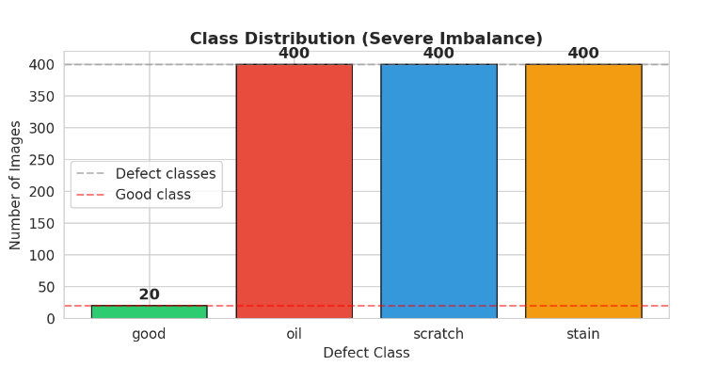
- Dataset Class Distribution

Model Workflow Diagram
In the study each of the eight backbone models (VGG16, ResNet50, MobileNetV2, EfficientNet-B0, DeiT-Small, Swin Transformer-Tiny, DINOv2-Small, ConvNeXt-Tiny) were loaded using pretrained weights from ImageNet. All backbone parameters were frozen, and no gradients were computed for them during training. The backbone networks were used to extract feature vectors from the training, validation, and test images. The features were stored on disk using FAISS (Facebook AI Similarity Search) indices and NumPy arrays, forming a persistent cache. The MLP head consists of two blocks, each containing a linear layer, batch normalization, ReLU activation, and dropout, followed by a final linear layer that outputs four class logits. The flowchart of all the necessary processes, including all the different approaches implemented in the study, can be seen in Fig-3.
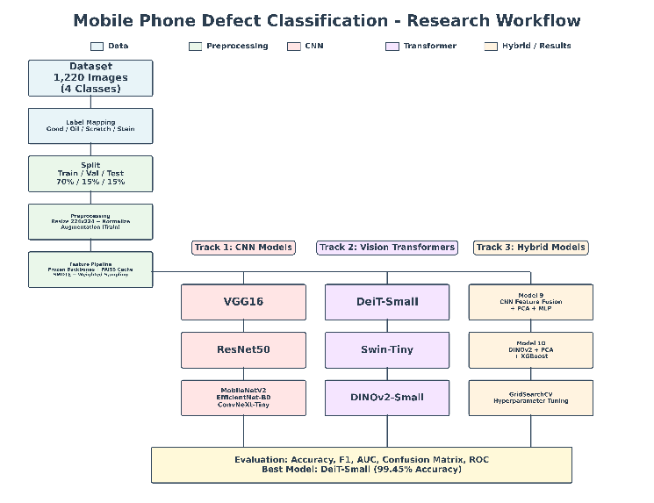
- Model Workflow Chart

Correlation Matrix
The study averaged each image at 224 × 224 resolution, and the Pearson correlation coefficient was computed between the flattened mean pixel vectors to form an inter-class correlation matrix. The analysis showed that the oil and scratch classes had the highest pixel-level similarity (r = 0.896), while the good class was most distinct from scratch (r = 0.489). Next, a feature-level correlation matrix was computed using the mean DeiT-Small feature vectors for each class. The Pearson correlation between six evaluation metrics (Accuracy, F1 Macro, F1 Weighted, Precision Macro, Recall Macro, and AUC Macro) was computed. The results showed that F1 Macro had the strongest correlation with Precision (r = 0.955), while Recall had a lower correlation with Accuracy (r = 0.475). The correlation matrix of all the relevant attributes of the dataset post data processing has been plotted in Fig-4.
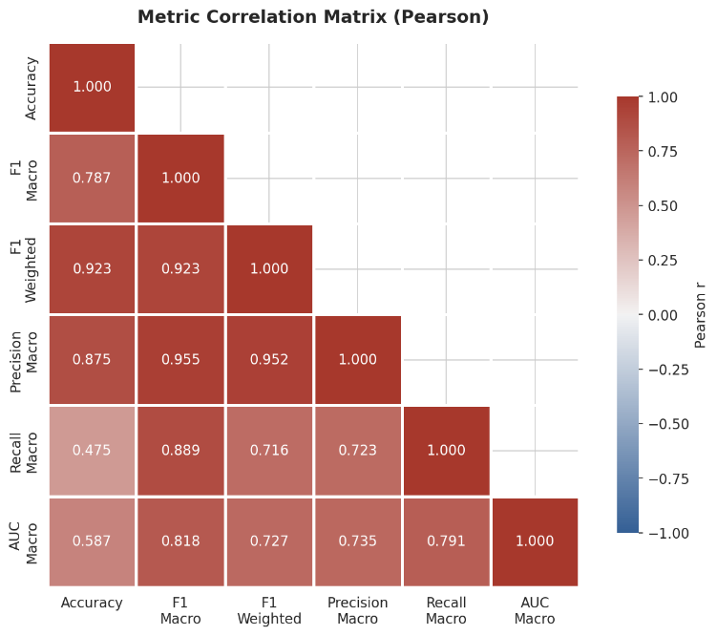
- Pearson correlation matrix of evaluation metrics

FAISS (Facebook AI Similarity Search)
In this study, FAISS was used to cache the feature vectors extracted by each backbone network. Once a backbone processes all the images and produces their feature vectors, those vectors are saved into a FAISS index file along with a NumPy array file on disk. An IndexFlatIP FAISS index was used to store feature vectors and retrieve them using inner product (cosine) similarity.

SMOTE (Synthetic Minority Over-sampling Technique
SMOTE is a technique which is used to fix class imbalance in a dataset. It creates new synthetic samples for the minority class. This study has an imbalance ration as good class has only 20 images in total and only 14 in the training set, while each defect class has around 280 training images. SMOTE was applied in the feature space rather than in the image space. The study extracts the feature vectors from a backbone, and then applied SMOTE to generate synthetic feature vectors for the good class.

PCA (Principal Component Analysis)
PCA is a mathematical technique reduces the number of dimensions in a dataset and tries to keep as much of the important information as possible. PCA was applied to reduce the features down to 512 dimensions while still keeping 97.6 percent of the total variance. PCA was used to reduce the high-dimensional feature vectors to 2 dimensions. PCA reduced the 384-dimensional DINOv2 features to 256 dimensions before passing them to the XGBoost classifier.

Technology Models
The study includes four traditional CNN architectures (VGG16, ResNet50, MobileNetV2, and EfficientNet-B0), three vision transformer models (DeiT-Small, Swin Transformer Tiny, and DINOv2-Small), one modern CNN (ConvNeXt-Tiny), and two hybrid approaches (a CNN feature ensemble and a DINOv2 plus XGBoost combination). A brief description of all the models with their parameters is given below.

VGG16
VGG16 is a deep convolutional neural network with 16 weight layers. It was initialized with ImageNet pretrained weights, and the classifier was truncated after the first fully connected layer to produce a 4096-dimensional feature vector per image. The extracted features were used to train a two-layer MLP head with 256 hidden units and 0.3 dropout. Training was performed using Adam with a learning rate of 0.001 and weight decay of 0.0001, cosine annealing learning rate scheduling, and early stopping with patience 7 over 50 epochs. VGG16 scored 96.72% accuracy, 0.8583 macro F1-score, and 0.9940 macro AUC.

ResNet50
ResNet50 is a 50-layer deep residual network that introduced skip connections. ResNet50 introduced residual connections enabling training of much deeper networks. The model contains 50 layers with skip connections in which gradients to flow directly through the network. The model was initialized with ImageNet V2 pretrained weights, and the final fully connected layer was replaced with an identity layer to produce 2048-dimensional feature vectors. The MLP classifier used a hidden dimension of 256 and a dropout rate of 0.3. It was trained with a learning rate of 0.001, weight decay of 0.0001, for 50 epochs with early stopping patience of 7. ResNet50 scored 98.91% accuracy, 0.9438 macro F1-score, and 0.9967 macro AUC.

MobileNetV2
MobileNetV2 is a lightweight architecture designed for mobile deployment. The model uses depth wise separable convolutions. This reduces computational cost and parameter count. The model expands the input to a higher-dimensional space and process it with depth wise convolutions. The model then projects the value back to a lower dimension with a residual connection. The MLP head used hidden dimension 256, dropout 0.3, learning rate 0.001, and weight decay 0.0001. MobileNetV2 scored 97.27% accuracy, 0.8783 macro F1-score, and 0.9931 macro-AUC.

EfficientNetB0
EfficientNetB0 is the base model of the EfficientNet family. It is specifically used for compound scaling method that uniformly scales network depth. EfficientNet helps in determining the optimal balance between three dimensions through neural search. The MLP head used hidden dimension 256, dropout 0.3, learning rate 0.001, and weight decay 0.0001. EfficientNet-B0 scored 97.81% accuracy, 0.9247 macro F1-score, and 0.9994 macro-AUC.

DeiT-Small (Data-efficient Image Transformer)
DeiT-Small is a vision transformer that was designed to train on ImageNet-scale data. It splits each image of 224 by 224 into 196 non-overlapping patches of 16 by 16 pixels. It projects each patch into a 384-dimensional embedding. An MLP head with hidden dimension 192 was used with a lower learning rate of 0.0005 and higher weight decay of 0.005. DeiT-Small scored 99.45% accuracy, 0.9958 macro F1-score, and 0.9998 macro-AUC.

Swin Transformer Tiny
Swin Transformer Tiny uses a hierarchical design with a shifted window based self-attention. It computes attention within local windows. It shifts the windows between layers to enable cross-window connections. The model produces 768-dimensional feature vectors. The MLP head used hidden dimension 256, learning rate 0.0005, and weight decay 0.005. Swin-Tiny scored 98.91% accuracy, 0.9438 macro F1-score, and 0.9991 macro-AUC.

DINOv2-Small
DINO V2 is used in this paper, which is a powerful AI model of Meta for understanding the images and extracting image information in numerical format. The model produces 384-dimensional feature vectors. The MLP head was used with hidden dimension 192 and lower dropout of 0.2 was used, with a learning rate of 0.001 and weight decay of 0.0001. DINOv2-Small scored 96.72% accuracy, 0.8373 macro F1-score, and 0.9852 macro-AUC.

ConvNeXt-Tiny
ConvNeXt-Tiny is a modernized convolutional neural network (CNN). It serves several design ideas from vision transformers to a pure convolutional architecture. It uses larger 7 by 7 depth wise convolution kernels, GELU activation functions, LayerNorm instead of BatchNorm. The model gives a CNN that matches or exceeds the performance of Swin Transformer. The model produces 768-dimensional feature vectors. The MLP head used hidden dimension 256, learning rate 0.0005, and weight decay 0.005. ConvNeXt-Tiny scored 97.81% accuracy, 0.8823 macro F1-score, and 0.9981 macro-AUC.

Hybrid CNN Ensemble
The hybrid model used in the study combines the feature representations from CNN backbones: ResNet50 (2048 dimensions), VGG16 (4096 dimensions), and MobileNetV2 (1280 dimensions). It forms a 7424-dimensional feature vector per image. PCA (Principal Component Analysis) was applied on the model to reduce this to 512 dimensions while retaining 97.6 percent of the total variance. The features were passed through the MLP classifier head with hidden dimension 256 and dropout 0.3, trained with learning rate 0.001 and weight decay 0.0001. The HybridCNN-Ensemble scored 97.27% accuracy, 0.8506 macro F1-score, and 0.9989 macro-AUC.

DINOv2 + XGBoost
The hybrid model used in the study pairs the DINOv2-Small foundation model features with XGBoost gradient boosting classifier. The 384-dimensional DINOv2 features were reduced to 256 dimensions using PCA. XGBoost was then trained through GridSearchCV using 3-fold stratified cross-validation. The search space included n_estimators in {100, 300, 500}, max_depth in {4, 6, 8}, learning_rate in {0.01, 0.05, 0.1}, and subsample in {0.8, 1.0}. DINOv2 + XGBoost scored 97.27% accuracy, 0.7358 macro F1-score, and 0.9820 macro-AUC.

Evaluation Matrix
Machine Learning is based on the analysis and testing of dataset. On processing the model with certain algorithms, gives the predictions. The accuracy of the models are calculated which is how well the model predicted the results. A comparison was illustrated between the predicted results and the actual values to test the accuracy and behavior of the model. Errors represent any false predictions made by the model. The evaluation metrics that are used are –

Precision
Precision computes the accuracy of positive predictions which is calculated as the ratio of true positives to all positive predictions (TP / (TP + FP)). High precision depicts fewer false alarms, which is necessary for applications where operating false positives is high costly.

Recall
Recall estimates the Integrity of detection, calculated as the ratio of true positives to all actual positive occurrences (TP / (TP + FN)). High recall depicts fewer missed detections, which is vital for applications in industries where missing a defect could have serious outcomes.

Accuracy
Classification accuracy shows the simplest and most intuitive evaluation metric which is calculated as the proportion of correct predictions among all predictions ((TP + TN) / (TP + TN + FP + FN)). Meanwhile accuracy provides a fast performance summarization, which can be misleading for disproportionate datasets where a naive classifier predicting the majority class attains high accuracy without useful learning.

F1-Score
Although not vaguely reported in all results, F1-score portray the harmonic mean of precision and recall, which provides a single metric that balances both concerns: F1 = 2 × (Precision × Recall) / (Precision + Recall). The harmonic mean certifies that both precision and recall must be high for a better F1-score; a model with very high precision but low recall (or vice versa) will have an average F1-score.

Results And Discussion
The comprehensive evaluation of ten different models reveals well defined performance characteristics across all four modeling paradigms. All the ten-model used in this paper achieved classification accuracy above 96%. This demonstrates the mobile phone defect detection and classification task can be very well observed by all the methodologies that are used in this research work. Table-2 shows the performance of the all the models used in this study, along with their performance scores.
- Analysis Model Results
Model | Accuracy | F1 Score | Precision | Recall
DeiT-Small | 0.9945 | 0.9958 | 0.9959 | 0.9958
ResNet50 | 0.9891 | 0.9438 | 0.9919 | 0.9125
Swin-Tiny | 0.9891 | 0.9438 | 0.9919 | 0.9125
EfficientNet-B0 | 0.9781 | 0.9247 | 0.8918 | 0.9833
ConvNeXt-Tiny | 0.9781 | 0.8823 | 0.8669 | 0.9042
MobileNetV2 | 0.9727 | 0.8783 | 0.8626 | 0.9000
DINOv2 + XGBoost | 0.9727 | 0.7358 | 0.7308 | 0.7417
HybridCNN-Ensemble | 0.9727 | 0.8506 | 0.8292 | 0.9000
VGG16 | 0.9672 | 0.8583 | 0.8381 | 0.8958
DINOv2-Small | 0.9672 | 0.8373 | 0.8172 | 0.8958

DeiT-Small achieved the highest accuracy of 99.45%. It was followed by ResNet50 and Swin Transformer Tiny at 98.91%, and EfficientNet-B0 and ConvNeXt-Tiny were at 97.81%. All the models achieved 96% accuracy by using only frozen pretrained features and lightweight MLP classifier heads. The performance gaps across all models used in the study were only 2.73 percentage points (from 99.45% to 96.72%). This shows that all the extracted features are highly suitable for this defect classification task. Fig-5 shows the model performance comparison by model category.
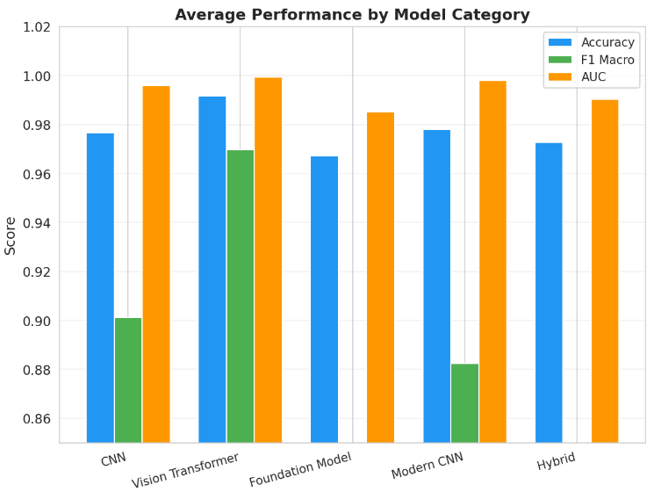
- Performance comparison for all model categories
DeiT-Small outperformed other models and it misclassified only a few on the images. Its confusion matrix showed 98.3% on the scratch class. Vision transformers models used in the paper (DeiT-Small and Swin-Tiny) achieved the highest average accuracy of 0.9918, followed by modern CNNs (ConvNeXt-Tiny) at 0.9781, traditional CNNs (VGG16, ResNet50, MobileNetV2, EfficientNet-B0) at 0.9768, and hybrid models at 0.9727. Fig-6 shows the model performance comparison for all the models used in the study.
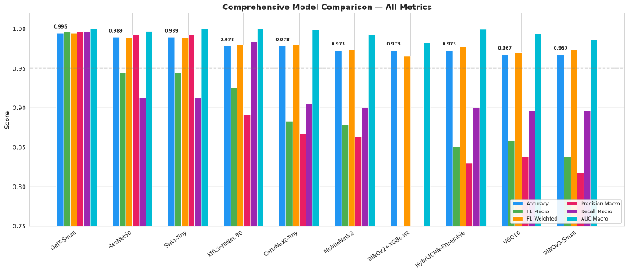
- Performance comparison for all model
The inter-model prediction heatmap shows that most model pairs achieved 96% to 99% of test predictions. The highest agreement was between ResNet50 and Swin-Tiny (100.0%). It was followed by ResNet50 and DeiT-Small (98.9%). The lowest agreement was between VGG16/DINOv2-Small and the HybridCNN-Ensemble (94.5%). The analysis clearly shows that the models that follow different architecture paradigms disagree the most. All the models achieved strong discrimination between oil and scratch. Fig-7 shows the inter model prediction heatmap for all the models used in the study.
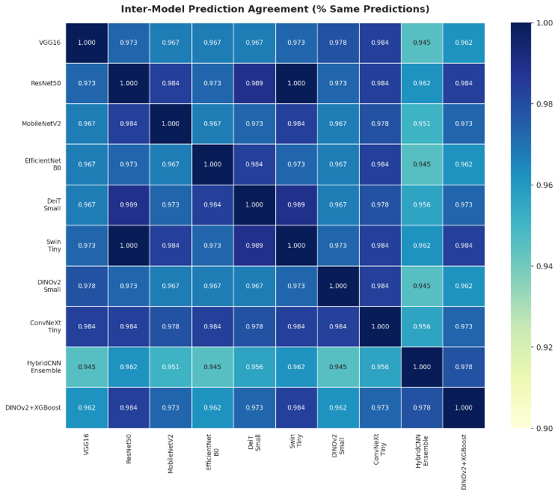
- Inter Model prediction heatmap

Conclusion And Future Work
This research evaluates different machine learning, deep learning algorithms and vision models for mobile defect detection using scans of mobiles. It uses ten deep learning models for four-class mobile phone surface defect classification. Eight individual architectures were used as traditional CNNs, vision transformers, and two hybrid approaches. The DeiT-Small vision transformer outperforms and achieved the best performance across all metrics with 99.45% accuracy, 0.9958 macro F1-score, and 0.9998 macro-AUC. All ten models achieved 96% accuracy, which shows that transfer learning with pretrained architectures are highly effective and efficient for industrial surface defect detection.
Future job models might be created and trained by averaging predictions from better and higher models to improve the results. Improvements like advanced data augmentation techniques like AutoAugment or learned augmentation policies can be used to improve the model generalization. Modern vision transformer architectures can be used for transfer learning can improve the results as well specially for CNN.

REFERENCES
- H. Han, R. Yang, S. Li, R. Hu and X. Li. SSGD: A smartphone screen glass dataset for defect detection. In ICASSP 2023-2023 IEEE International Conference on Acoustics, Speech and Signal Processing (ICASSP) pp. 1-5, IEEE, 2023.
- A. Liang, Q. Wang and X. Wu. Context-enhanced network with spatial-aware graph for smartphone screen defect detection. Sensors, 24(11), p.3430, 2024.
- İ. Akgül. A novel deep learning method for detecting defects in mobile phone screen surface based on machine vision. Sakarya University Journal of Science, 27(2), pp.442-451, 2023.
- L. Meiju, Z. Rui, G. Xifeng and Z. Junrui, August. Application of improved Otsu threshold segmentation algorithm in mobile phone screen defect detection. In 2020 Chinese Control And Decision Conference (CCDC) (pp. 4919-4924). IEEE, 2020.
- Z. Chen, Y. Zha, Z. Wu and D. Zeng. Detection of mobile phone screen defect based on faster R-CNN fusion model. In 2021 China Automation Congress (CAC) pp. 6601-6606. IEEE, 2021.
- G. Yang, H. Lai and Q. Zhou. Visual defects detection model of mobile phone screen. Journal of Intelligent & Fuzzy Systems, 43(4), pp.4335-4349, 2022
- M. U. M. Bhutta, S. Aslam, P. Yun, J. Jiao and M. Liu. Smart-inspect: micro scale localization and classification of smartphone glass defects for industrial automation. In 2020 IEEE/RSJ International Conference on Intelligent Robots and Systems (IROS) (pp. 2860-2865). IEEE, 2020.
- K. Chen, X. Peng and Y. Xiao. Screen-Printed Ink Protrusion Defect Detection Method for Mobile Phone Cover Glass. Academic Journal of Engineering and Technology Science, 9(1), pp.13-23, 2026.
- C. Zhang, G. Shi, H. Li, M. Yang, Y. Li, Z. Bing, W. Chen, Z. Wang, F. R. Yu and V. C. Leung. Circuit Board Welding Defect Detection based on Industrial IoVT. IEEE Internet of Things Journal, 2026.
- P. Wu, H. Zhou, Y. Yu, Z. Miao, Q. Pan, X. Zhang and J. Gao. SSGDD-YOLO: multiscale feature fusion and multiattention-based yolo for smartphone screen glass defect detection. IEEE Sensors Journal, 25(4), pp.6982-6994, 2025.
- R. Mohandas, M. Southern, C. Fitzpatrick and M. Hayes. Deep learning enabled computer vision in remanufacturing and refurbishment applications: defect detection and grading for smart phones. Journal of Remanufacturing, 15(1), pp.65-95, 2025.
- Y. Zhou, X. Shen, Z. Ma, K. Huang, X. Zheng and Y. Min. A Novel Glass Defect Detection Method for Mobile Phone Cover Combining Vision Transformer and Faster R-CNN. In 2024 IEEE 8th International Conference on Vision, Image and Signal Processing (ICVISP) pp. 1-6, IEEE, 2024.
- D. Zhang, P. Wei, X. Li, J. Yang and C. Liu. Convolutional Neural Networks based Defect Detection Method for Smart Meter LCD Screen. In 2024 7th International Conference on Data Science and Information Technology (DSIT) pp. 1-5, IEEE, 2024.
- Y. Mao, J. Yuan, Y. Zhu and Y. Jiang. Surface defect detection of smartphone glass based on deep learning. The International Journal of Advanced Manufacturing Technology, 127(11), pp.5817-5829, 2023.
- C. Zhou, M. Liu, S. Zhang, P. Wei and B. Chen. A graph-based two-stage classification network for mobile screen defect inspection. Frontiers of Information Technology & Electronic Engineering, 24(2), pp.203-216, 2023.
- Mobile Phone Defect Segmentation Dataset, Kaggle, Girish, 2023, Accessed: 2026-03-01. https://www.kaggle.com/datasets/girish17019/mobile-phone-defect-segmentation-dataset

